Web Design and Development

4COSC011W

Report

Author: Minura pasan Haputhanthri

Student ID: w1840262(20201029)

Group Number: K-8

Student Role:3

Link(s) to WebSite

URL:

1. Introduction 2

2. Technical Discussion 2

3. Webpage Validation Statement 8

4. Janet 8

References 8

Appendices 9

Appendix A: Code 9

Appendix B: Screenshots 32

Appendix C: Screenshots: Webpage Validation Evidence 34

Appendix D: Individual Statement 38

# Introduction

Section guidelines:

1. Dimuthu Chanaka w1870624 (student 1)

Chamuditha Prabash w1867687 (student 2)

Minura Pasan w1840262 (student 3)

Pinidu Wekunugoda w1070098 (student 4)

| **Group Coursework Meetings** (minimum 6 meetings, e.g., one per week) | | |
| --- | --- | --- |
| **1** | **Date & Time** | Feb 18 - 8pm |
| **Objective:** | shared the four tasks related to it. |
| **Attended:** | yes |
| **Your Contribution:** | I accepted the relevant work |
| **2** | **Date & Time:** | Feb 25 - 10pm |
| **Objective:** | Choose a topic / Discussed abouth main web page |
| **Attended:** | yes |
| **Your Contribution:** | Contribute to creating the main web page |
| **3** | **Date & Time:** | March 11 - 8pm |
| **Objective:** | Each did some work related to the selected student roll |
| **Attended:** | yes |
| **Your Contribution:** | I did some work related to the student roll |
| **4**  **5**  **6** | **Date & Time:** | March 18 - 12am |
| **Objective:** | Talk about stylesheets |
| **Attended:** | yes |
| **Your Contribution:** | Comment on the design paper |
| **Date & Time:** | March 24 - 10 pm |
| **Objective:** | correct the errors |
| **Attended:** | yes |
| **Your Contribution:** | correct the errors |
| **Date & Time:** | March 28 11pm |
|  | **Objective:** | Linking web pages |
|  | **Attended:** | yes |
|  | **Your Contribution:** | Linking my page to main web pages |

# Technical Discussion

**Student Details.**

All my pages use Verdana, Geneva, Tahoma, sans-serif fonts. Our distribution navigation bar and logo are used equally on every page.



**Student details**

Navigation bar and footer are same in this page also. This page contains 4 photos of our team members. There, when the mouse point is moved to each photo, the information of the relevant student is displayed. Each student's name, IIT number, group activity related to the student's role, and each student's Facebook account and Instagram account are listed.



When the mouse point is moved to the box corresponding to each student's information, the black and yellow color of the box changes to green and purple.

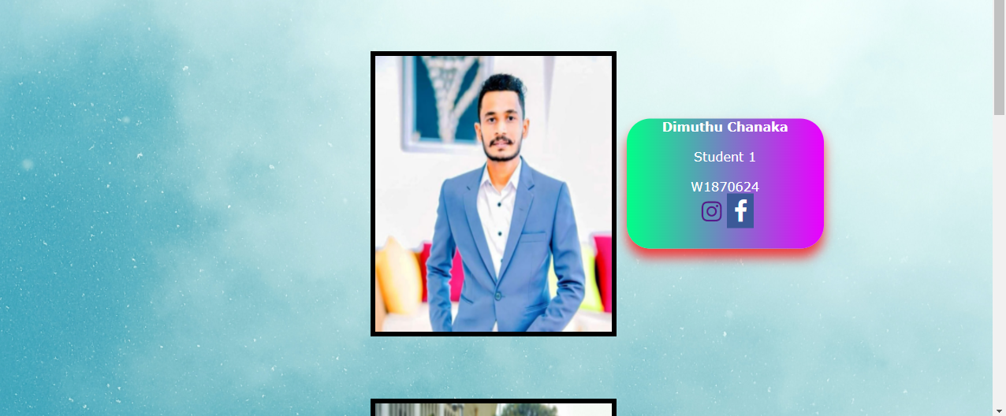

CSS has been used for this.

**Quiz Start Page**

Navigation bar and footer are same in this page also. Here we provide an introduction to the quiz and an explanation to the contestant of the terms of the quiz.

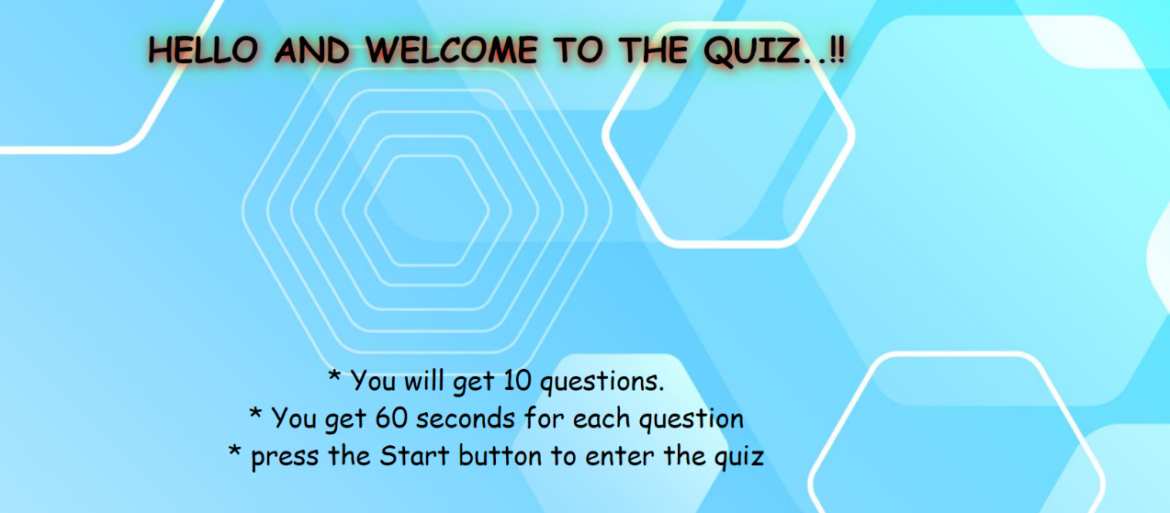

In the same way, when you move the mouse point to the Start button, it changes to orange and yellow, purple and blue.

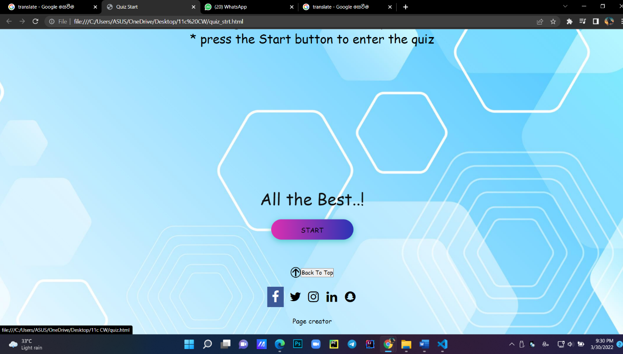

**Quiz page**

The contestant is given the opportunity to answer 10 questions in 60 seconds.The contestant is also made to see the time it takes for it. When providing answers, the contestant has the ability to change the answer he / she has given.

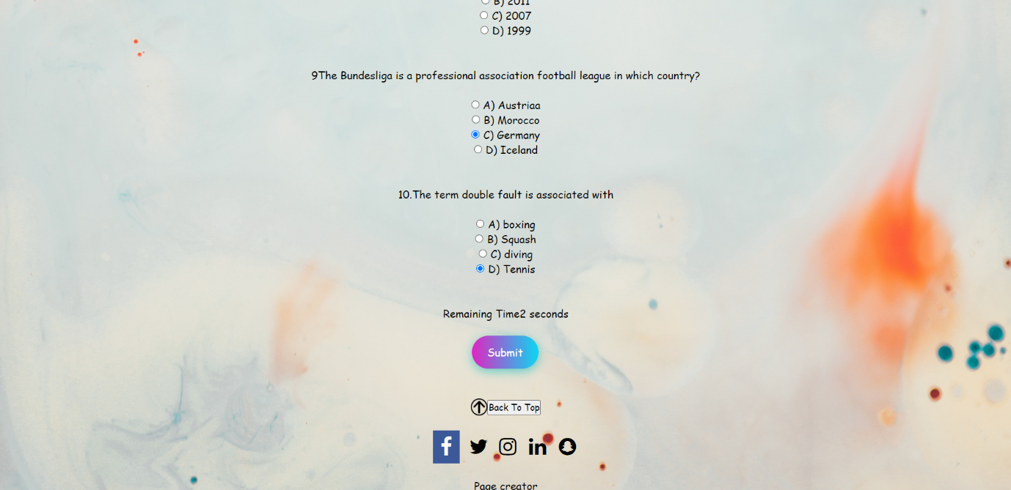

Here the contestant is finally made to know whether the answers he gives are correct or incorrect and whether he has not provided the answers himself. If his answer is correct, it will be light pink If the answer is incorrect it will appear in red. If the answer is no, it will be shown in blue.

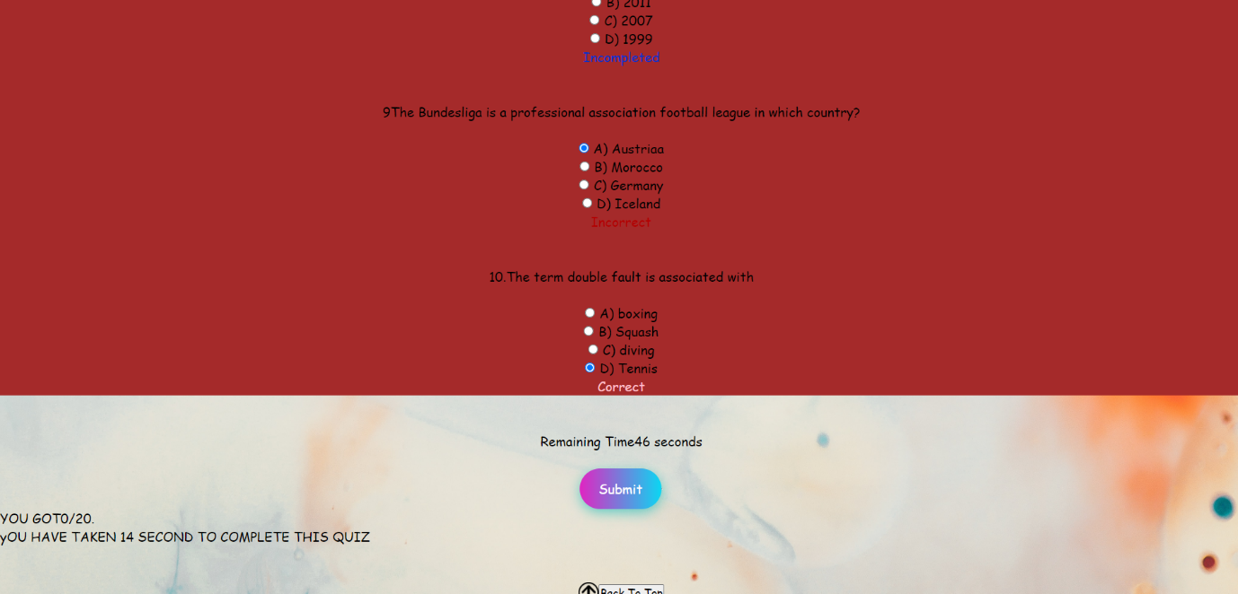

Here we give 2 points each for the correct answer given by the contestant. If it is more than 16 points, the color of the background will be light blue. If the score is between 12-16 it will appear in gray. If the score is between 8-12 it will appear in green. If less than 8, the background is brown. JS and CSS were used for this

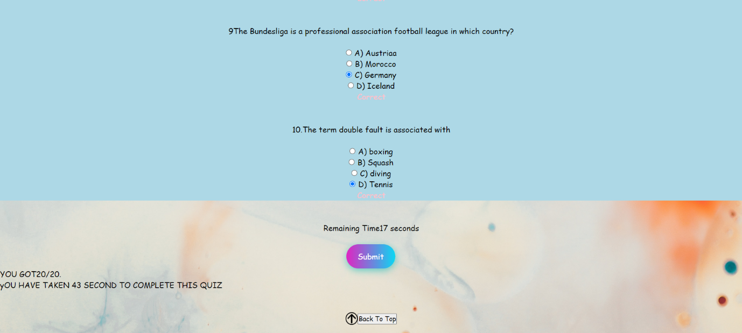

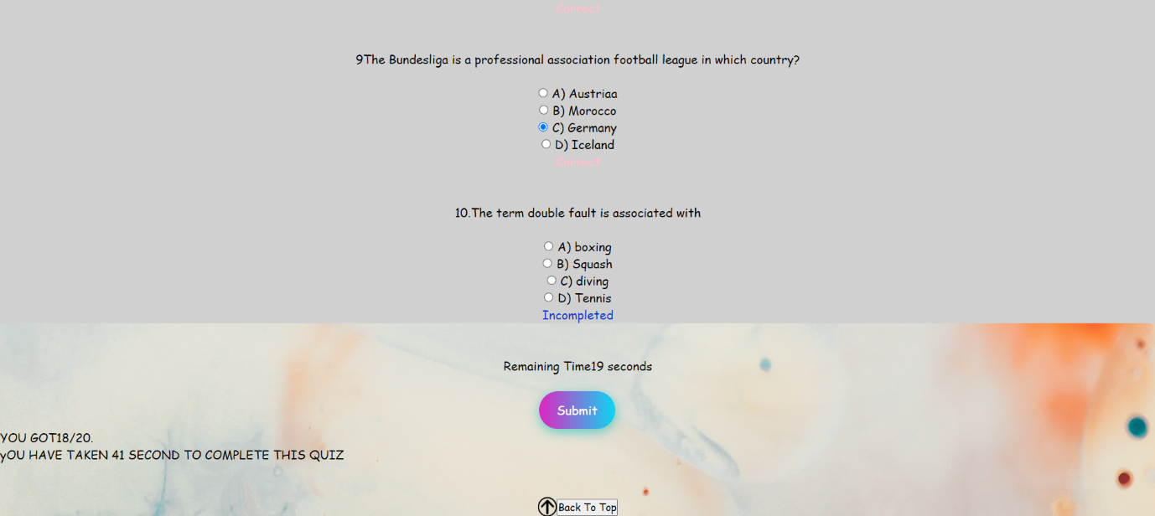

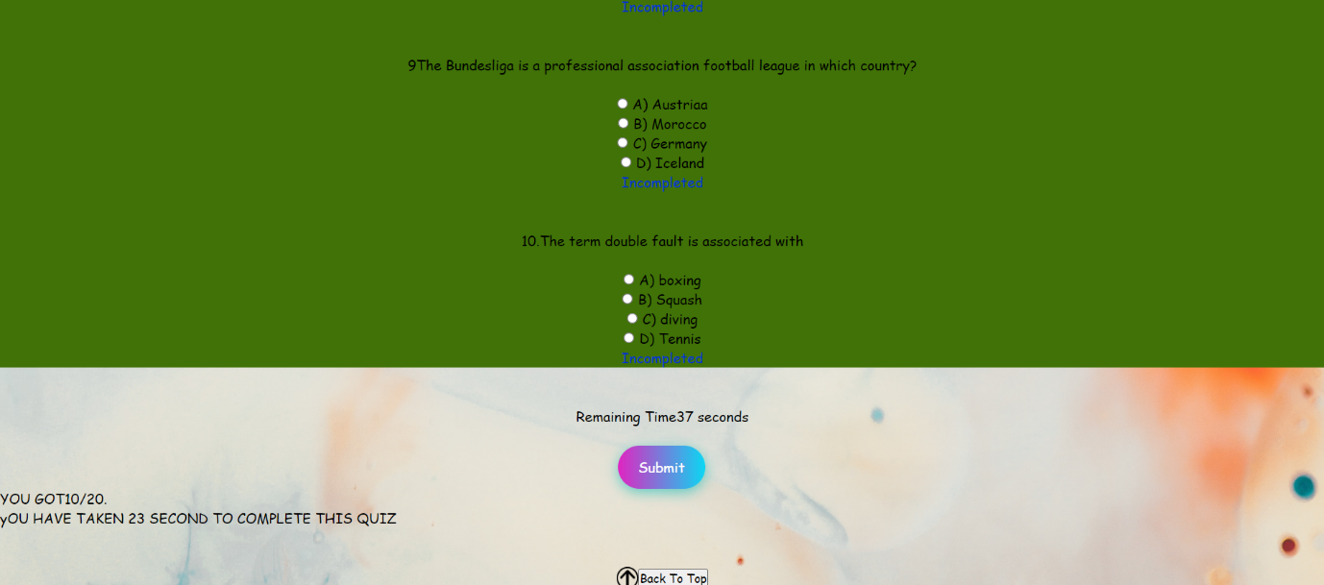

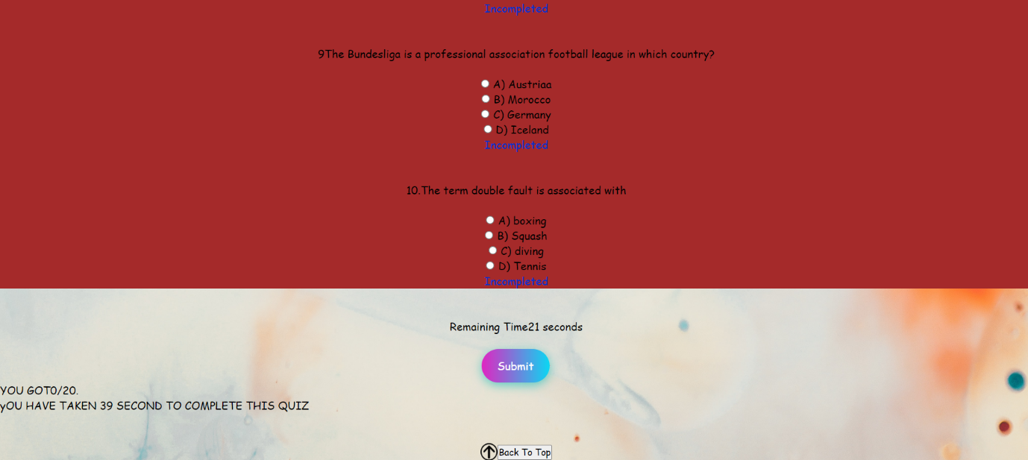

# Webpage Validation Statement

Briefly state which three of your web pages validated without errors. Put the screen shots of the validation results in Appendix C.

# Janet

# The Janet Regulations are not to be confused with our website. My social affair and I are confident that we have survived the storm and that our page has not been involved in any unlawful behavior. Our website does not contain any libelous photos or illegal recordings, and specific work was chosen so that it would not interfere with or interrupt the work of other apprentices.

# References

<https://www.w3schools.com/tags/tag_button.asp>

<https://www.w3schools.com/tags/tag_form.asp>

Stack Overflow. (2021). Newest “javascript” Questions. [online] Available at: https://stackoverflow.com/questions/tagged/javascript [Accessed 21 Jul. 2021].

W3schools.com. (2021). HTML Tutorial. [online] Available at: https://www.w3schools.com/html/default.asp [Accessed 21 Jul. 2021]

# Appendices

## Appendix A: Code

**Student Details**

**Html file**

<!DOCTYPE html>

<html lang="en">

<head>

<meta charset="UTF-8">

<meta http-equiv="X-UA-Compatible" content="IE=edge">

<meta name="viewport" content="width=device-width, initial-scale=1.0">

<title>Student Details</title>

</head>

<h1>Student Details</h1>

<link rel="stylesheet" href="details.css">

<link rel="stylesheet" href="https://cdnjs.cloudflare.com/ajax/libs/font-awesome/4.7.0/css/font-awesome.min.css">

<br><br>

<body>

<div class="backgroundimg">

<!--Navigation bar-->

<div class="menu">

<img src="img/logo2.png" alt="pageLogo" class="logo">

</div>

<div class="container">

<img src="img/dimuthu.jpeg" alt="Avatar" class="image1" width = "300" heightt= "390">

<div class="overlay1">

<div class="box">

<div class="btn-hover color-1"><p><b>Dimuthu Chanaka</b></p><br>Student 1</p><br><p>W1870624</p>

<a href="https://www.instagram.com/dimuthu_jay/"><i class="fa fa-instagram" style="font-size: 30px;"></i></a>

<a href="https://www.facebook.com/profile.php?id=100012749344797"><i class="fa fa-facebook" style="font-size: 30px;"></i></a>

</div>

</div>

</div>

</div>

<br><br><br><br>

<div class="container">

<img src="img/chamuiditha.jpeg" alt="Avatar" class="image2" width = "300" heightt= "390">

<div class="overlay2">

<div class="btn-hover color-1"><p><b>Chamuditha Prabhash</b></p><br>Student 2</p><br><p>W1867687</p><br>

<a href="https://www.instagram.com/invites/contact/?i=1ew4a9koffbbq&utm_content=20m7zup"><i class="fa fa-instagram" style="font-size: 30px;"></i></a>

<a href="https://www.facebook.com/profile.php?id=100014921914506"><i class="fa fa-facebook" style="font-size: 30px;"></i></a></div>

</div>

</div>

<br><br><br><br>

<div class="container">

<img src="img/minura.jpeg" alt="Avatar" class="image3" width = "300" heightt= "390">

<div class="overlay3">

<div class="btn-hover color-1"><p><b>Miunra Pasan</b></p><br>Student 3</p><br><p>W1840262</p><br>

<a href="https://www.instagram.com/minura.pasan/"><i class="fa fa-instagram" style="font-size: 30px;"></i></a>

<a href="hhttps://www.facebook.com/minura.pasan"><i class="fa fa-facebook" style="font-size: 30px;"></i></a>

</div>

</div>

</div>

<br><br><br><br>

<div class="container">

<img src="img/pinidu.jpg" alt="Avatar" class="image4" width = "300" heightt= "390">

<div class="overlay4">

<div class="btn-hover color-1"><p><b>Pinindu Wekunagoda</b></p><br>Student 4</p><br><p>W1870098</p><br>

<a href="https://www.instagram.com/minura.pasan/"><i class="fa fa-instagram" style="font-size: 30px;"></i></a>

<a href="hhttps://www.facebook.com/minura.pasan"><i class="fa fa-facebook" style="font-size: 30px;"></i></a>

</div>

</div>

</div>

<br><br>

<!--footer-->

<footer>

<br><br>

<div class="back">

<img src="img/arrow.jpg" alt="arrow" width="25" height="25"><a href="#top"><button>Back To Top</button></a>

</div>

<div class="social">

<br>

<a href="https://www.facebook.com"><i class="fa fa-facebook" style="font-size: 30px;"></i></a>

<a href="https://twitter.com"><i class="fa fa-twitter" style="font-size: 30px;"></i></a>

<a href="https://www.instagram.com"><i class="fa fa-instagram" style="font-size: 30px;"></i></a>

<a href="https://lk.linkedin.com"><i class="fa fa-linkedin" style="font-size: 30px;"></i></a>

<a href="https://www.snapchat.com/"><i class="fa fa-snapchat" style="font-size: 30px;"></i></a>

</div>

</footer>

<br>

<div class = "creater" >

<p>Page create by :- Miunura Pasan</p></div>

<br>

</body>

</html>

**Css file**

*{margin: 0;

padding: 0;

font-family: Verdana, Geneva, Tahoma, sans-serif;

}

.menu{

width: 85%;

margin: auto;

padding: 35px 0;

display: flex;

align-items: center;

justify-content: space-between;

font-size: 18px;

}

.logo{

width: 225px;

}

body{

height: 100%;

margin: 0;

background-color: black;

}

.backgroundimg{

background-image: url("img/back8.jpg");

height: 100%;

width: 100%;

background-repeat: no-repeat,repeat-x,repeat-y;

background-size: cover;

background-position: center;

}

h1{

font-family: 'poppins';

text-align: center;

color: rgb(226, 223, 57);

font-size: 50px;

text-decoration: underline;

text-shadow: 4px 4px 16px white,0 0 8px red;

background-image: backgroumgimg;;

}

.container{

margin-left: auto;

margin-right: auto;

position: relative;

width: 25%;

}

.image1{

border: 6px solid ;

width: 300px;

height: 350px;

}

.image2{

display: block;

width: 300px;

height: 325px;

border: 6px solid;

}

.image3{

width: 300px;

height: 350px;

border: 6px solid;

display: block;

}

.image4{

width: 300px;

height: 390px;

border: 6px solid;

display: block;

}

.overlay1{

position: absolute;

top: 50%;

left: 100px;

height: 10%;

width: 500px;

opacity: 0;

transition: .5s ease;

}

.overlay2{

position: absolute;

top: 30%;

right: 400px;

height: 10%;

width: 500px;

opacity: 0;

transition: .5s ease;

}

.container:hover .overlay2 {

height:50%;

opacity: 1;

}

.container:hover .overlay1 {

width:100%;

opacity: 1;

}

.overlay3{

position: absolute;

top: 30%;

left: 100px;

height: 10%;

width: 500px;

opacity: 0;

transition: .5s ease;

}

.overlay4{

position: absolute;

top: 35%;

right: 700px;

height: 30%;

width: 500px;

opacity: 0;

transition: .5s ease;

}

.container:hover .overlay3 {

height:50%;

opacity: 1;

}

.container:hover .overlay4 {

width:50%;

opacity: 1;

}

.btn-hover{

overflow: hidden;

color: rgb(255, 255, 255);

font-size: 20px;

position: absolute;

top: 50%;

left: 100%;

-ms-transform: translate(-70%,-70%);

-webkit-transform: translate(-70%,-70%);

transform: translate(-70%,-70%);

text-align: center;

width: 250px;

right: 500px;

left: 400px;

font-size: 16px;

font-weight: 600px;

color: rgb(255, 255, 255);

cursor: pointer;

height: 165px;

text-align: center;

border: none;

background-size: 300% 100%;

border-radius: 30px;

-o-transition: all .5s ease-in-out;

-webkit-transition: all .5s ease-in-out;

transition: all .5s ease-in-out;

}

.btn-hover:hover{

background-position: 100% 0;

-o-transition: all .4s ease-in-out;

-webkit-transition: all .4s ease-in-out;

transition: all .5s ease-in-out;

}

.btn-hover.color-1{

background-image: linear-gradient(to right, #f8f406, #000000, #00ff88, #ea00ff);

box-shadow: 0 12px 15px 0 rgba(255, 0, 0, 0.75);

}

.back{

text-align: center;

}

.footer{

margin-top: 10%;

bottom: 0;

width: auto ;

background-color: rgba(248, 131, 35, 0.568);

text-align: center;

}

footer a{

color: aliceblue;

}

footer a:hover{

color: antiquewhite;

}

.soical > a {

font-size: 24px;

width: 40px;

height: 40px;

line-height: 40px;

display: inline-block;

text-align: center;

border-radius: 50%;

border: 3px solid #ccc;

margin: 0 8px;

color: inherit;

opacity: 0.75;

padding: 20px;

}

.social {

text-align:center;

}

.fa-facebook{

background: #3B5998;

color: white;

}

.fa{

padding: 7px;

text-align: center;

text-decoration: none;

font-size: 30px;

width: 20px;

}

.creater{

text-align: center;

}

**Quiz Start Page**

**Html file**

<!DOCTYPE html>

<html lang="en">

<head>

<meta charset="UTF-8">

<meta http-equiv="X-UA-Compatible" content="IE=edge">

<meta name="viewport" content="width=device-width, initial-scale=1.0">

<title>Quiz Start</title>

<!--css file & socail media-->

<link rel="stylesheet" href="quiz_strt.css">

<link rel="stylesheet" href="https://cdnjs.cloudflare.com/ajax/libs/font-awesome/4.7.0/css/font-awesome.min.css">

</head>

<body>

<!--back ground img-->

<div class="backgroundimage">

<div id="nevigetionbar">

<p id="sitename">Sports Zone</p>

<img src="img/logo2.png" alt="pageLogo" class="logo">

</div>

<div class="WELCOME"><h2>HELLO AND WELCOME TO THE QUIZ..!!</h2></div>

<div class="introduction">

<p>* You will get 10 questions.</p>

<p>* You get 60 seconds for each question</p>

<p>* press the Start button to enter the quiz</p>

</div>

<br>

<div class="best">

<p>All the Best..!</p>

</div>

<br>

<div class="start">

<div class="center">

<a href="quiz.html"><input id="button" type="button" value="START" class="btn-hover color-1"></a>

</div>

</div>

<br><br><br>

<div class="center">

<img src="img/arrow.jpg" alt="arrow" width="25" height="25"><a href="#top" class="back"><button>Back To Top</button></a>

</div>

<!--footer-->

<div class ="footer">

<div class="social">

<br>

<a href="https://www.facebook.com"><i class="fa fa-facebook" style="font-size: 30px;"></i></a>

<a href="https://twitter.com"><i class="fa fa-twitter" style="font-size: 30px;"></i></a>

<a href="https://www.instagram.com"><i class="fa fa-instagram" style="font-size: 30px;"></i></a>

<a href="https://lk.linkedin.com"><i class="fa fa-linkedin" style="font-size: 30px;"></i></a>

<a href="https://www.snapchat.com/"><i class="fa fa-snapchat" style="font-size: 30px;"></i></a>

</div>

</div>

<br>

<div class = "creater" >

<p>Page create by :- Miunura Pasan</p></div>

<br>

</div>

</body>

</html>

**Css file**

*{

box-sizing: border-box;

margin: 0;

padding: 0;

font-family: cursive;

}

#sitename{

text-align: center;

font-family: 'Zen Tokyo Zoo', cursive;

font-size: 40px;

}

.backgroundimage{

background-image: url(img/qback2.jpg);

background-position: center;

background-size: cover;

background-repeat: no-repeat;

margin-top: auto;

}

.WELCOME{

text-align: center;

font-size: 25px;

color: azure;

color: rgba(0, 0, 0, 0.978);

text-shadow: 2px 2px 10px rgb(255, 0, 0),0 0 30px rgb(3, 255, 37);

}

.logo{

width: 225px;

}

.best{

text-align: center;

font-family: Georgia, 'Times New Roman', Times, serif;

font-size: 40px;

color: rgb(14, 14, 14);

font-family: 'Trebuchet MS', 'Lucida Sans Unicode', 'Lucida Grande', 'Lucida Sans', Arial, sans-serif;

}

.introduction{

text-align: center;

padding: 320px;

font-size: 30px;

color: black ;

}

#button{

background-color: rgb(119, 133, 122);

border-color: coral;

color: black;

padding: 15px 30px 15px 30px;

align-items: center;

justify-content: center;

}

.center{

display: flex;

justify-content: center;

align-items: center;

}

ul{

background-color: white;

margin: 0px;

padding-top: 60px;

}

li{

display: inline;

}

li a:hover{

font-size: 250px;

text-shadow: 1px 2px gold;

line-height: 0% ;

}

.back{

text-align: center;

}

.list{

text-align: center;

background-color: white;

padding: 20px;

}

a{

text-decoration: none;

color: black;

}

.soical > a {

font-size: 24px;

width: 40px;

height: 40px;

line-height: 40px;

display: inline-block;

text-align: center;

border-radius: 50%;

border: 3px solid #ccc;

margin: 0 8px;

color: inherit;

opacity: 0.75;

padding: 20px;

}

.social {

text-align:center;

}

.fa-facebook{

background: #3B5998;

color: white;

}

.fa{

padding: 10px;

text-align: center;

text-decoration: none;

font-size: 30px;

width: 40px;

}

.btn-hover{

width: 200px;

right: 500px;

left: 400px;

font-size: 16px;

font-weight: 600px;

color: rgb(255, 255, 255);

cursor: pointer;

height: 50px;

text-align: center;

border: none;

background-size: 300% 100%;

border-radius: 50px;

-o-transition: all .5s ease-in-out;

-webkit-transition: all .5s ease-in-out;

transition: all .5s ease-in-out;

}

.btn-hover:hover{

background-position: 100% 0;

-o-transition: all .4s ease-in-out;

-webkit-transition: all .4s ease-in-out;

transition: all .5s ease-in-out;

}

.btn-hover.color-1{

background-image: linear-gradient(to right, #e12b25, #d4e440, #dd30b2, #2b34b6);

box-shadow: 0 4px 15px 0 rgba(49,196,190,0.75);

}

.creater{

text-align: center;

}

**Quiz Page**

**Htmal & js file**

<!DOCTYPE html>

<html lang="en">

<head>

<meta charset="UTF-8">

<meta http-equiv="X-UA-Compatible" content="IE=edge">

<meta name="viewport" content="width=device-width, initial-scale=1.0">

<title>Quiz</title>

<link rel="stylesheet" href="quiz.css" type="text/css">

<link rel="stylesheet" href="https://cdnjs.cloudflare.com/ajax/libs/font-awesome/4.7.0/css/font-awesome.min.css">

</head>

<body>

<div class="backgroundimage">

<!--navigation bar-->

<div class="menu">

<img src="img/logo2.png" alt="pageLogo" class="logo">

</div>

<div id="header">

<h1>Sports Zone Quiz</h1>

</div>

<form id="form1">

<div class="question">

<p>1.The Olympics are held every how many years? </p>

<input class="inputStyles" type="radio" name="1" value="ans1"> A) 2<br>

<input class="inputStyles" type="radio" name="1" value="ans2"> B) 4<br>

<input class="inputStyles" type="radio" name="1" value="ans3"> C) 8<br>

<input class="inputStyles" type="radio" name="1" value="ans4"> D) 3<br>

<p id="answer1"></p>

<br><br>

<p>2.How many players are on a baseball team?</p><br>

<input class="inputStyles" type="radio" name="2" value="ans1"> A) 7 players <br>

<input class="inputStyles" type="radio" name="2" value="ans2"> B) 6 players <br>

<input class="inputStyles" type="radio" name="2" value="ans3"> C) 9 players <br>

<input class="inputStyles" type="radio" name="2" value="ans4"> D) 8 players <br>

<p id="answer2"></p>

<br><br>

<p>3 How many minutes was the longest recorded point in the history of tennis?</p><br>

<input class="inputStyles" type="radio" name="3" value="ans1"> A) 29 minutes <br>

<input class="inputStyles" type="radio" name="3" value="ans2"> B) 41 minutes <br>

<input class="inputStyles" type="radio" name="3" value="ans3"> C) 22 minutes <br>

<input class="inputStyles" type="radio" name="3" value="ans4"> D) 33 minutes <br>

<p id="answer3"></p>

<br><br>

<p>4 How much does an NFL football weigh?</p><br>

<input class="inputStyles" type="radio" name="4" value="ans1"> A) 4 pound <br>

<input class="inputStyles" type="radio" name="4" value="ans2"> B) 1 pound <br>

<input class="inputStyles" type="radio" name="4" value="ans3"> C) 3 pound <br>

<input class="inputStyles" type="radio" name="4" value="ans4"> D) 6 pound <br>

<p id="answer4"></p>

<br><br>

<p>5.What was the first city to host the Olympics twice?</p><br>

<input class="inputStyles" type="radio" name="5" value="ans1"> A) Nepal <br>

<input class="inputStyles" type="radio" name="5" value="ans2"> B) Yemen <br>

<input class="inputStyles" type="radio" name="5" value="ans3"> C) Italy <br>

<input class="inputStyles" type="radio" name="5" value="ans4"> D) Paris <br>

<p id="answer5"></p>

<br><br>

<p>6.How many rings are there on the Olympic flag?</p><br>

<input class="inputStyles" type="radio" name="6" value="ans1"> A) 4 <br>

<input class="inputStyles" type="radio" name="6" value="ans2"> B) 5 <br>

<input class="inputStyles" type="radio" name="6" value="ans3"> C) 6 <br>

<input class="inputStyles" type="radio" name="6" value="ans4"> D) 7 <br>

<p id="answer6"></p>

<br><br>

<p>7.The 2016 Summer Olympics will be held in which country?</p><br>

<input class="inputStyles" type="radio" name="7" value="ans1"> A) Sweden <br>

<input class="inputStyles" type="radio" name="7" value="ans2"> B) Greece <br>

<input class="inputStyles" type="radio" name="7" value="ans3"> C) Brazil <br>

<input class="inputStyles" type="radio" name="7" value="ans4"> D) Norway <br>

<p id="answer7"></p>

<br><br>

<p>8.In which year did Sri Lanka win a World Cup?</p><br>

<input class="inputStyles" type="radio" name="8" value="ans1"> A) 1996 <br>

<input class="inputStyles" type="radio" name="8" value="ans2"> B) 2011 <br>

<input class="inputStyles" type="radio" name="8" value="ans3"> C) 2007 <br>

<input class="inputStyles" type="radio" name="8" value="ans4"> D) 1999 <br>

<p id="answer8"></p>

<br><br>

<p>9The Bundesliga is a professional association football league in which country?</p><br>

<input class="inputStyles" type="radio" name="9" value="ans1"> A) Austriaa<br>

<input class="inputStyles" type="radio" name="9" value="ans2"> B) Morocco <br>

<input class="inputStyles" type="radio" name="9" value="ans3"> C) Germany <br>

<input class="inputStyles" type="radio" name="9" value="ans4"> D) Iceland <br>

<p id="answer9"></p>

<br><br>

<p>10.The term double fault is associated with</p><br>

<input class="inputStyles" type="radio" name="9" value="ans1"> A) boxing <br>

<input class="inputStyles" type="radio" name="9" value="ans2"> B) Squash <br>

<input class="inputStyles" type="radio" name="9" value="ans3"> C) diving <br>

<input class="inputStyles" type="radio" name="9" value="ans4"> D) Tennis <br>

<p id="answer10"></p>

</div>

</form>

<br><br>

<div class="countdown">

<span id="timer"></span>

</div>

<br>

<div>

<div class="center">

<button type="button" onclick="checkAnswer()" class="btn-hover color-1">Submit</button>

<hr>

</div>

</div>

<div id="after_submit">

<p id="score"></p>

<p id="time"></p>

</div>

<br><br>

<div class="center">

<img src="img/arrow.jpg" alt="arrow" width="25" height="25"><a href="#top" class="back"><button>Back To Top</button></a>

</div>

<!--footer-->

<div class="footer">

<div class="social">

<br>

<a href="https://www.facebook.com"><i class="fa fa-facebook" style="font-size: 30px;"></i></a>

<a href="https://twitter.com"><i class="fa fa-twitter" style="font-size: 30px;"></i></a>

<a href="https://www.instagram.com"><i class="fa fa-instagram" style="font-size: 30px;"></i></a>

<a href="https://lk.linkedin.com"><i class="fa fa-linkedin" style="font-size: 30px;"></i></a>

<a href="https://www.snapchat.com/"><i class="fa fa-snapchat" style="font-size: 30px;"></i></a>

<br><br>

<p>Page create by :- Miunura Pasan</p>

<br>

</div>

</div>

</div>

<script>

var forml = document.querySelector("form")

var timer;

var sec = 60;

var min =0;

var sec2;

window.onload = function timecount(){

timer = setInterval(function(){

sec--;

if (sec == 0){

clearTimeout(timer);

checkAnswer()

}

else if(sec==0){

sec=60;

}

document.getElementById("timer").innerHTML = "Remaining Time" + sec + " " + "seconds";},1000);

}

function checkAnswer(){

clearTimeout(timer);

var correct = 0;

var ans1Arr = document.getElementsByName("1");

var ans2Arr = document.getElementsByName("2");

var ans3Arr = document.getElementsByName("3");

var ans4Arr = document.getElementsByName("4");

var ans5Arr = document.getElementsByName("5");

var ans6Arr = document.getElementsByName("6");

var ans7Arr = document.getElementsByName("7");

var ans8Arr = document.getElementsByName("8");

var ans9Arr = document.getElementsByName("9");

var ans10Arr = document.getElementsByName("10");

var ans1Select = " "; var ans2Select = " "; var ans3Select = " "; var ans4Select = " "; var ans5Select = " ";

var ans6Select = " "; var ans7Select = " "; var ans8Select = " "; var ans9Select = " "; var ans10Select = " ";

//question1

for (var i = 0; i < ans1Arr.length;i++){

if (ans1Arr[i].checked){

ans1Select = ans1Arr[i].value;

}

}

if (ans1Select == " ") {

document.getElementById("answer1").innerHTML = "Incompleted" ;

document.getElementById("answer1").style.color = "#0033cc";

}

else if (ans1Select == "ans2") {

document.getElementById("answer1").innerHTML = "Correct" ;

correct +=2;

document.getElementById("answer1").style.color = "gold";

}

else {

document.getElementById("answer1").innerHTML = "Incorrect" ;

correct--;

document.getElementById("answer1").style.color = "#b30000";

}

//question2

for (var i=0; i< ans2Arr.length;i++){

if (ans2Arr[i].checked){

ans2Select = ans2Arr[i].value;

}

}

if (ans2Select == " ") {

document.getElementById("answer2").innerHTML = "Incompleted" ;

document.getElementById("answer2").style.color = "#0033cc";

}

else if (ans2Select == "ans3") {

document.getElementById("answer2").innerHTML = "Correct" ;

correct +=2;

document.getElementById("answer2").style.color = "gold";

}

else {

document.getElementById("answer2").innerHTML = "Incorrect" ;

correct--;

document.getElementById("answer2").style.color = "#b30000";

}

//question3

for (var i=0; i< ans1Arr.length;i++){

if (ans3Arr[i].checked){

ans3Select = ans3Arr[i].value;

}

}

if (ans3Select == " ") {

document.getElementById("answer3").innerHTML = "Incompleted" ;

correct--;

document.getElementById("answer3").style.color = "#0033cc";

}

else if (ans3Select == "ans1") {

document.getElementById("answer3").innerHTML = "Correct" ;

correct +=2;

document.getElementById("answer3").style.color = "gold";

}

else {

document.getElementById("answer3").innerHTML = "Incorrect" ;

correct--;

document.getElementById("answer3").style.color = "#b30000";

}

//question4

for (var i=0; i< ans4Arr.length;i++){

if (ans4Arr[i].checked){

ans4Select = ans4Arr[i].value;

}

}

if (ans4Select == " ") {

document.getElementById("answer4").innerHTML = "Incompleted" ;

correct--;

document.getElementById("answer4").style.color = "#0033cc";

}

else if (ans4Select == "ans2") {

document.getElementById("answer4").innerHTML = "Correct" ;

correct +=2;

document.getElementById("answer4").style.color = "#gold";

}

else {

document.getElementById("answer4").innerHTML = "Incorrect" ;

correct--;

document.getElementById("answer4").style.color = "#b30000";

}

//question5

for (var i=0; i< ans5Arr.length;i++){

if (ans5Arr[i].checked){

ans5Select = ans5Arr[i].value;

}

}

if (ans5Select == " ") {

document.getElementById("answer5").innerHTML = "Incompleted" ;

correct--;

document.getElementById("answer5").style.color = "#0033cc";

}

else if (ans5Select == "ans4") {

document.getElementById("answer5").innerHTML = "Correct" ;

correct +=2;

document.getElementById("answer5").style.color = "gold";

}

else {

document.getElementById("answer5").innerHTML = "Incorrect" ;

correct--;

document.getElementById("answer5").style.color = "#b30000";

}

//question6

for (var i=0; i< ans6Arr.length;i++){

if (ans6Arr[i].checked){

ans6Select = ans6Arr[i].value;

}

}

if (ans6Select == " ") {

document.getElementById("answer6").innerHTML = "Incompleted" ;

correct--;

document.getElementById("answer6").style.color = "#0033cc";

}

else if (ans6Select == "ans2") {

document.getElementById("answer6").innerHTML = "Correct" ;

correct +=2;

document.getElementById("answer6").style.color = "#gold";

}

else {

document.getElementById("answer6").innerHTML = "Incorrect" ;

correct--;

document.getElementById("answer6").style.color = "#b30000";

}

//question7

for (var i=0; i< ans7Arr.length;i++){

if (ans7Arr[i].checked){

ans7Select = ans7Arr[i].value;

}

}

if (ans7Select == " ") {

document.getElementById("answer7").innerHTML = "Incompleted" ;

correct--;

document.getElementById("answer7").style.color = "#0033cc";

}

else if (ans7Select == "ans3") {

document.getElementById("answer7").innerHTML = "Correct" ;

correct +=2;

document.getElementById("answer7").style.color = "#gold";

}

else {

document.getElementById("answer7").innerHTML = "Incorrect" ;

correct--;

document.getElementById("answer7").style.color = "#b30000";

}

//question8

for (var i=0; i< ans8Arr.length;i++){

if (ans8Arr[i].checked){

ans8Select = ans8Arr[i].value;

}

}

if (ans8Select == " ") {

document.getElementById("answer8").innerHTML = "Incompleted" ;

correct--;

document.getElementById("answer8").style.color = "#0033cc";

}

else if (ans8Select == "ans1") {

document.getElementById("answer8").innerHTML = "Correct" ;

correct +=2;

document.getElementById("answer8").style.color = "gold";

}

else {

document.getElementById("answer8").innerHTML = "Incorrect" ;

correct--;

document.getElementById("answer8").style.color = "#b30000";

}

//question9

for (var i=0; i< ans9Arr.length;i++){

if (ans9Arr[i].checked){

ans9Select = ans9Arr[i].value;

}

}

if (ans9Select == " ") {

document.getElementById("answer9").innerHTML = "Incompleted" ;

document.getElementById("answer9").style.color = "#0033cc";

}

else if (ans9Select == "ans3") {

document.getElementById("answer9").innerHTML = "Correct" ;

correct +=2;

document.getElementById("answer9").style.color = "gold";

}

else {

document.getElementById("answer9").innerHTML = "Incorrect" ;

correct--;

document.getElementById("answer9").style.color = "#b30000";

}

//question10

for (var i=0; i< ans10Arr.length;i++){

if (ans10Arr[i].checked){

ans9Select = ans10Arr[i].value;

}

}

if (ans10Select == " ") {

document.getElementById("answer9").innerHTML = "Incompleted" ;

document.getElementById("answer9").style.color = "#0033cc";

}

else if (ans10Select == "ans4") {

document.getElementById("answer9").innerHTML = "Correct" ;

correct +=2;

document.getElementById("answer9").style.color = "gold";

}

else {

document.getElementById("answer9").innerHTML = "Incorrect" ;

correct--;

document.getElementById("answer9").style.color = "#b30000";

}

if (correct < 0){

correct = 0;

}

if (correct == 20) {

document.getElementById("form1").style.backgroundImage = "img/wi.back2.png"

}

else if (correct > 16) {

document.getElementById("form1").style.backgroundColor = "#d9ff66";

}

else if (correct > 12) {

document.getElementById("form1").style.backgroundColor = "#ffff33";

}

else if (correct >8 ) {

document.getElementById("form1").style.backgroundColor = "#47d1d1";

}

else {

document.getElementById("form1").style.backgroundColor = "#b3d9ff";

}

sec2 = 60 - sec;

document.getElementById("after_submit").style.visibility = "visible";

document.getElementById("score").innerHTML = "YOU GOT" + correct + "/20.";

document.getElementById("time").innerHTML = "yOU HAVE TAKEN" + " " + sec2 + " "+"SECOND TO COMPLATE THIS QUIZ";

}

</script>

</body>

</html>

**Css file**

*{

box-sizing: border-box;

margin: 0;

padding: 0;

font-family: cursive;

}

#header{

color: darkred;

font-family: 'Segoe UI', Tahoma, Geneva, Verdana, sans-serif;

text-align: center;

}

.backgroundimage{

background-image: url(img/qback2.jpg);

background-position: center;

background-size: cover;

background-repeat: no-repeat;

margin-top: auto;

}

.body{

width: 100px;

margin-top: 20px;

color: black;

background-color: aquamarine;

}

.question{

clear: both;

padding-top: 20px;

text-align: center;

}

.center{

display: flex;

justify-content: center;

align-items: center;

}

.timer{

color: darkred;

}

.countdown{

text-align: center;

}

#form1{

margin: 0%;

width: 100%;

text-align: center;

}

.logo{

width: 225px;

width: 20%;

}

ol{

background: white;

margin:0px;

padding: top 60px;

}

.li{

display: inline;

}

li a{

padding-left: 50px;

padding-right: 50px;

font-size: 25px;

}

li a:hover{

font-size: 250%;

text-shadow: 1px 2px rgb(254, 255, 195);

line-height: 0%;

}

.list{

text-align: center;

background-color: white;

padding: 20px;

}

.button{

text-align: center;

}

#submit{

font-size: medium;

}

.soical > a {

font-size: 24px;

width: 40px;

height: 40px;

line-height: 40px;

display: inline-block;

text-align: center;

border-radius: 50%;

border: 3px solid #ccc;

margin: 0 8px;

color: inherit;

opacity: 0.75;

padding: 20px;

}

.social {

text-align:center;

}

.fa-facebook{

background: #3B5998;

color: white;

}

.fa{

padding: 10px;

text-align: center;

text-decoration: none;

font-size: 30px;

width: 40px;

}

a{

text-decoration: none;

color: black;

}

.btn-hover{

width: 100px;

right: 500px;

left: 400px;

font-size: 16px;

font-weight: 600px;

color: rgb(255, 255, 255);

cursor: pointer;

height: 50px;

text-align: center;

border: none;

background-size: 300% 100%;

border-radius: 50px;

-o-transition: all .5s ease-in-out;

-webkit-transition: all .5s ease-in-out;

transition: all .5s ease-in-out;

}

.btn-hover:hover{

background-position: 100% 0;

-o-transition: all .4s ease-in-out;

-webkit-transition: all .4s ease-in-out;

transition: all .5s ease-in-out;

}

.btn-hover.color-1{

background-image: linear-gradient(to right, #e125c2, #0bd8f3, #ff0000, #fcf700);

box-shadow: 0 4px 15px 0 rgba(49,196,190,0.75);

}

## Appendix B: Screenshots

**Student Details**

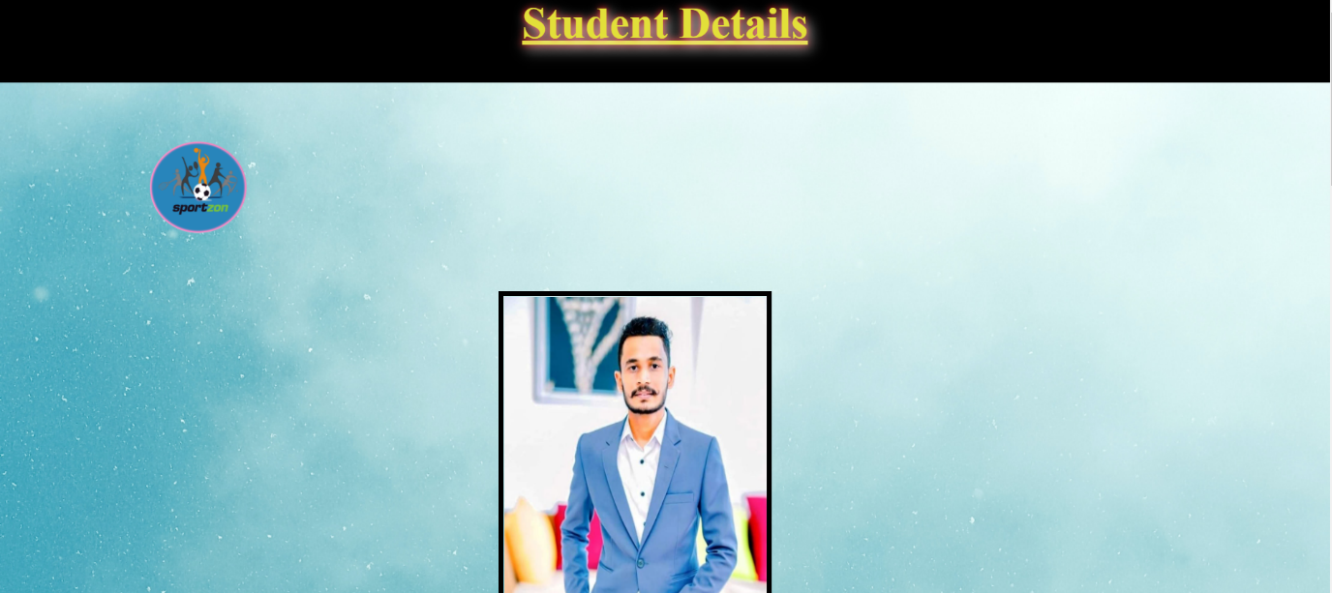

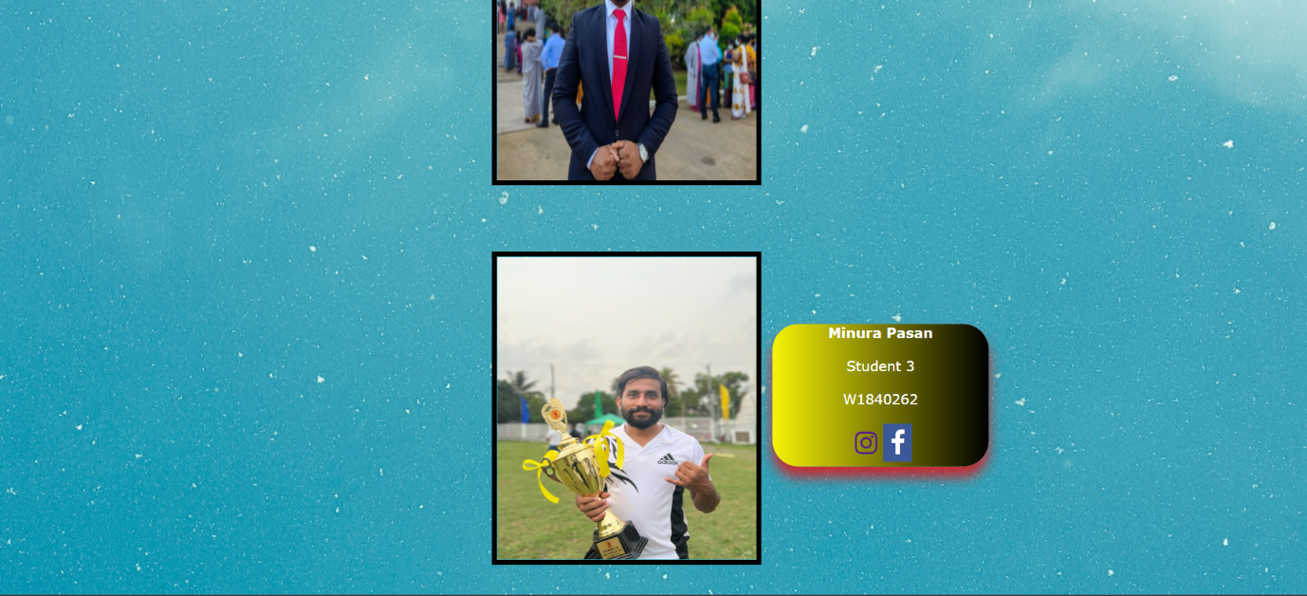

**Quiz Start Page**

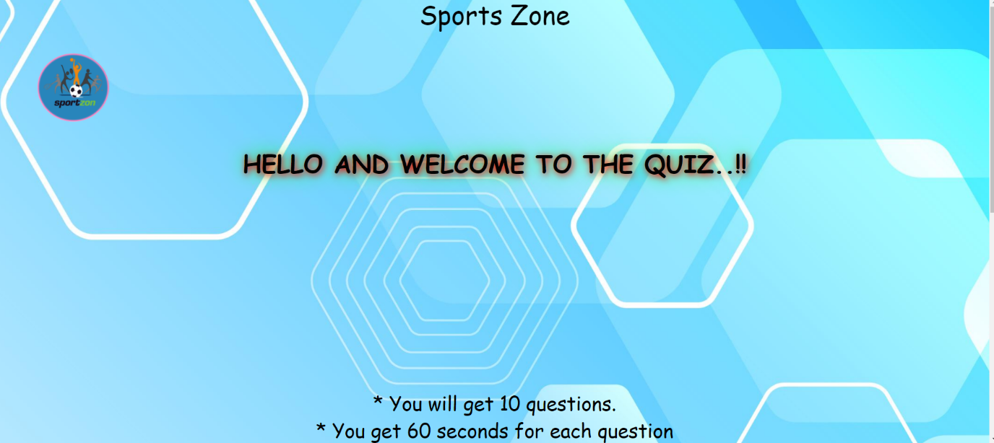

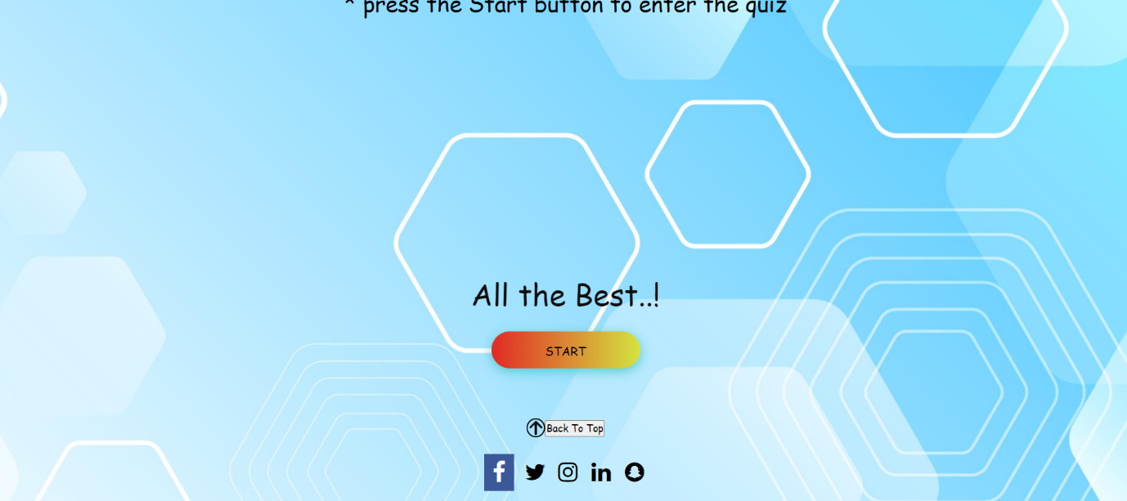

**Quiz page**

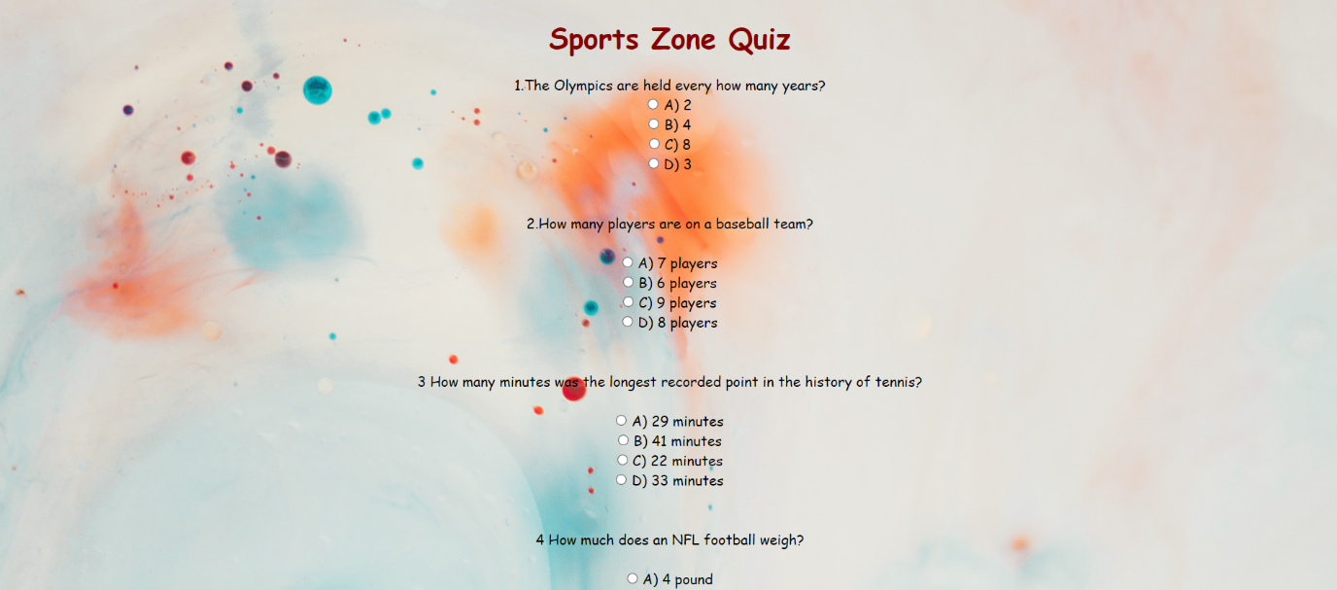



## Appendix C: Screenshots - Webpage Validation Evidence

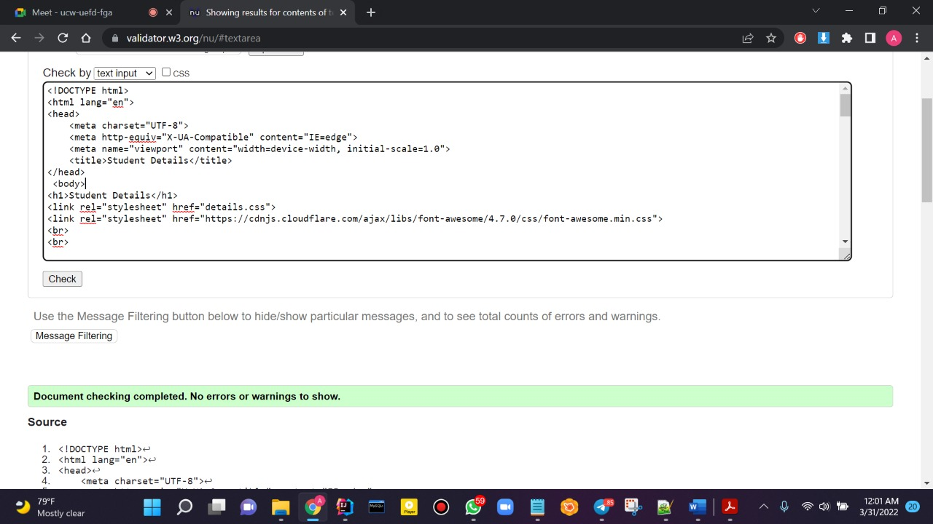

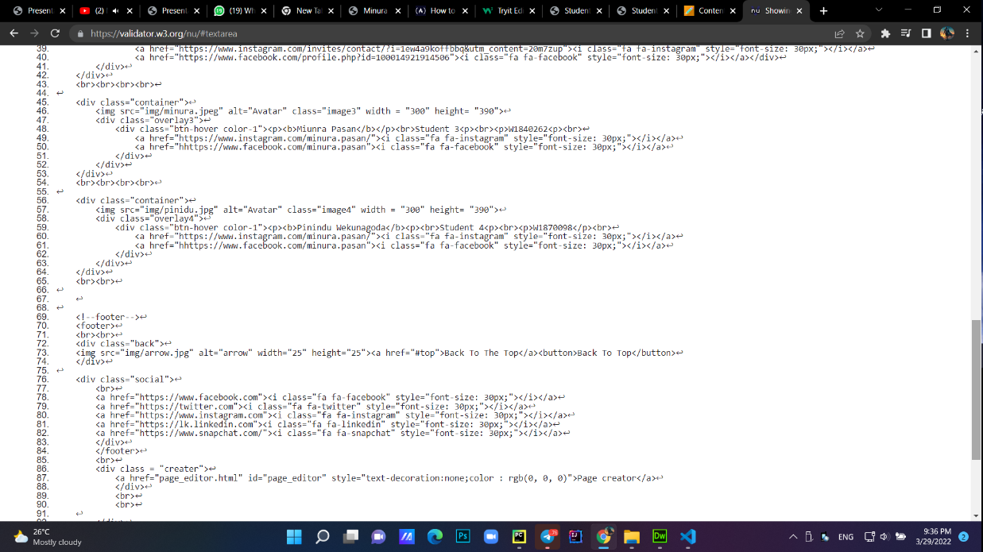

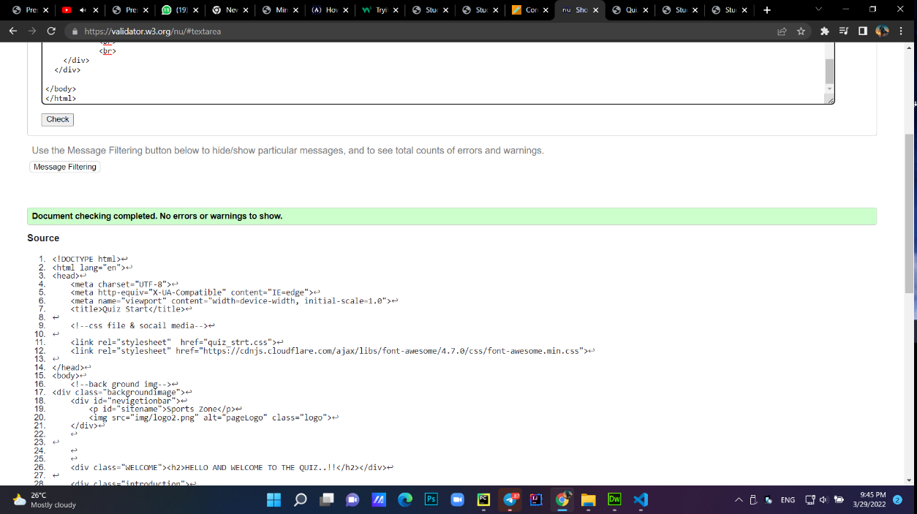

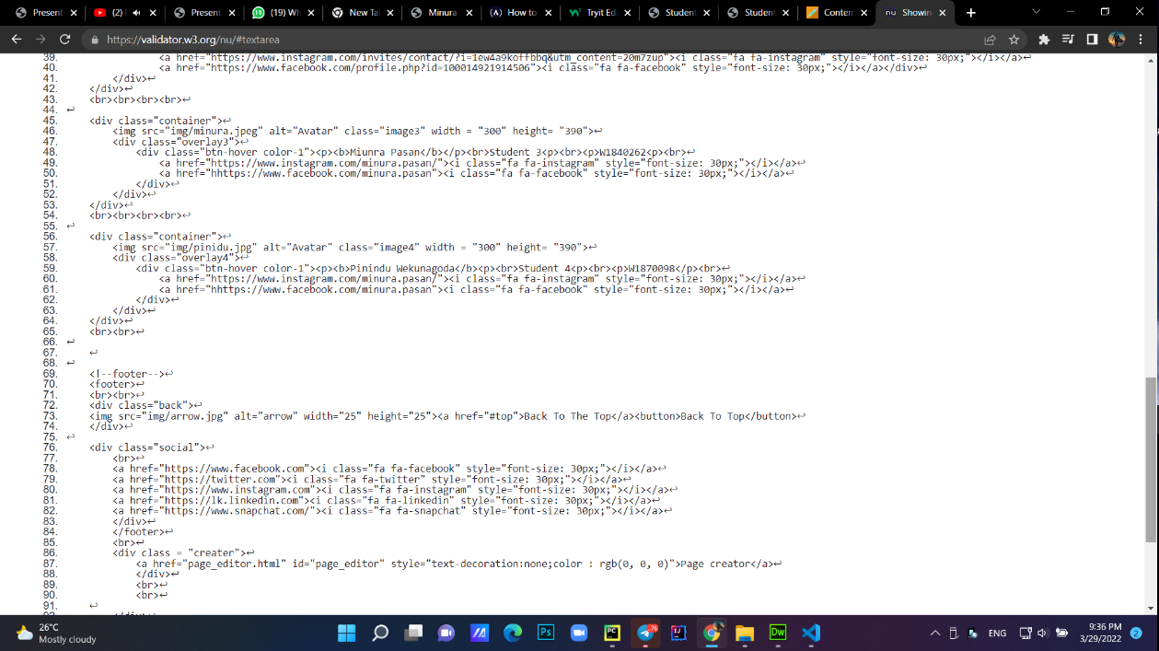

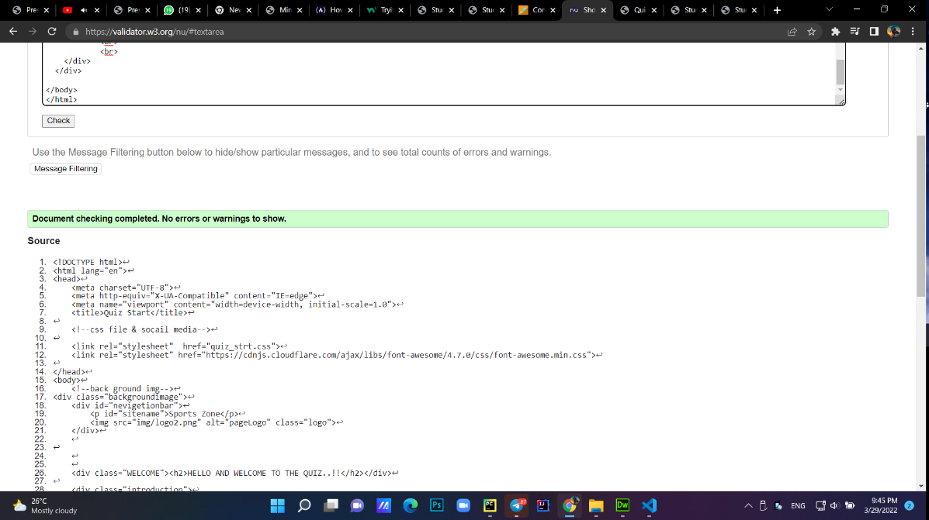

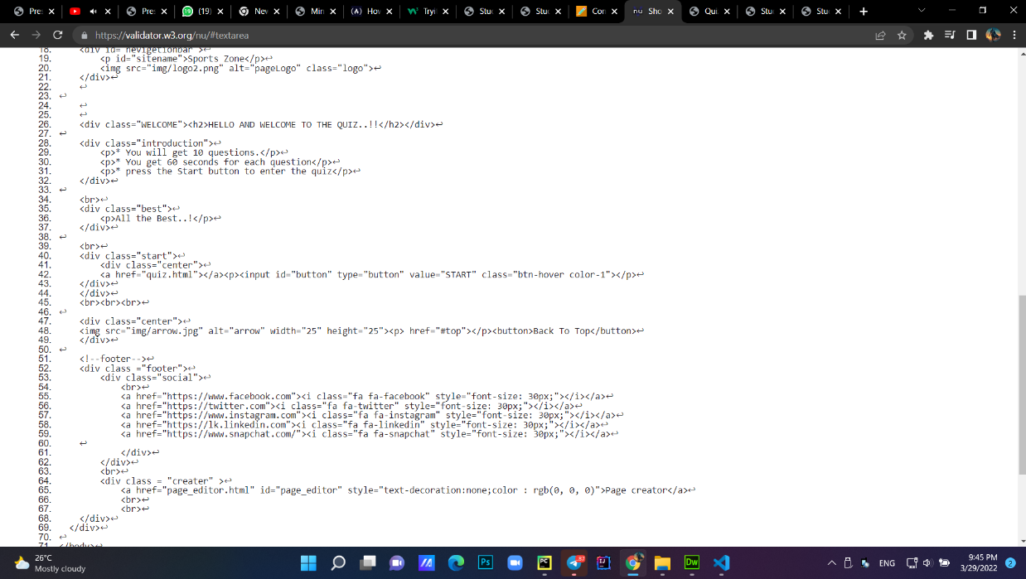

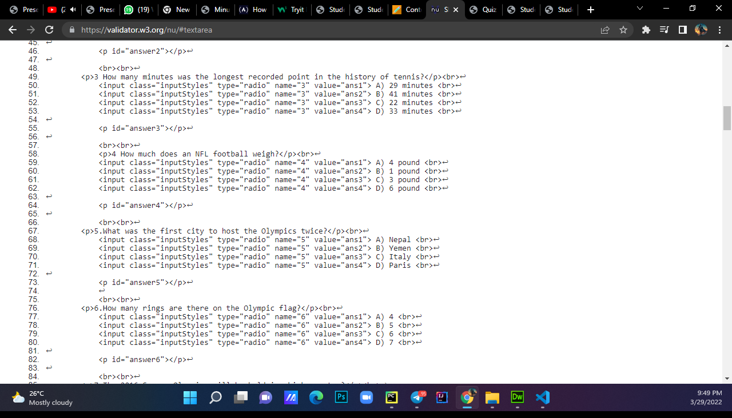

## Appendix D: Individual Statement

| Student Name: | Minura Pasan | Student Id: | W1840262 |
| --- | --- | --- | --- |
| State what tasks you carried out in the project. | | | |
| Create the student details page  Create the quiz page  Create logo | | | |
| State what you enjoyed and did not enjoy about teamwork. | | | |
| I shared my knowledge with these other members, and I believe that this group work has given me an advantage. Working as a team is pleasurable since all of our team members are committed to doing their best in this course work, and I believe it is the most logical thing we can do to complete our assignments as planned. | | | |
| State what you learnt about teamwork. | | | |
| It is the simplest way to develop our knowledge without a tutor because we can learn what we don't know and teach others what they don't know when we discuss. | | | |
| State what skills you gained/learnt from undertaking the project. | | | |
| Improve your communication abilities.  Learn how to collaborate with others. | | | |
| State any strengths about yourself that emerged whilst undertaking the project. | | | |
| Time management  Creative ideas | | | |
| State any weaknesses about yourself that emerged whilst undertaking the project. | | | |
| I made same pages again, but this time with more creativity. I notice a lot of flaws in myself in this course work, and if I had to do it again, I will address those flaws and do better. | | | |
| State how you would do things better if you were to undertake the project again. | | | |
| I made same pages again, but this time with more creativity. I notice a lot of flaws in myself in this course work, and if I had to do it again, I will address those flaws and do better. | | | |
| Additional general or project specific comments: | | | |
|  | | | |